Challenge:

Easy Phish

# Challenge Description:

Customers of secure-startup.com have been recieving some very convincing phishing emails, can you figure out why?

# Context:

## Domain to lookup / Recon would be Secure-startup.com

* + - We use a tool to scan / search up the DNS records on the Domain

# Notes:

* I'm just gonna use a web-tool for this,
  + - https://mxtoolbox.com/

# Challenge:

* Just scan the domain for anything Phishy / Flaggy

# Flag:

* First we go to Mxtoolbox.com and enter the domain we want to search the records for.
* The first scan wasn't a success for anything interesting, lets try looking up the DMARC record
* The Second Scan gave us half the flag, we need to find the other half.
* After we keep scanning for different dns records like SPF / MX, we Get a hit on the SPF records, for the other part of the flag, meaning we have it all.

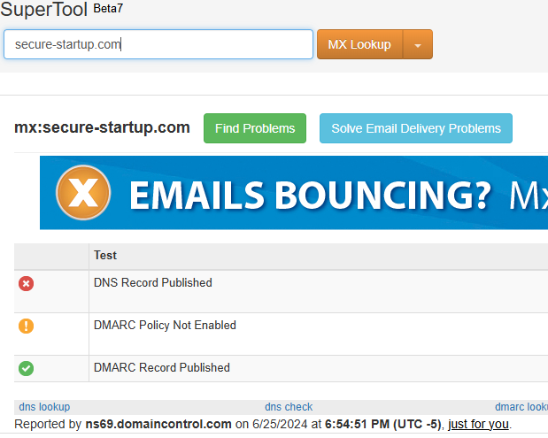

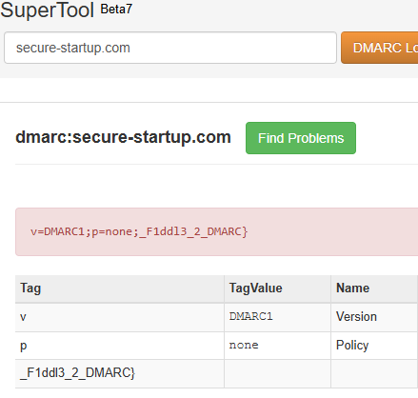

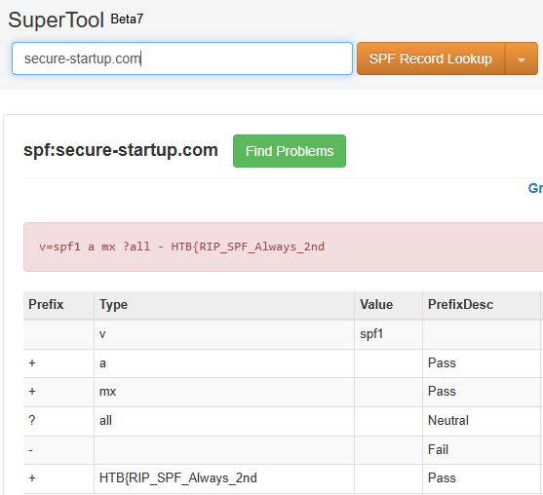

We get the flag : HTB{RIP_SPF_Always_2nd_F1ddl3_2_DMARC}

From Birdo